Jokes in Soviet Estonia

A paper presented to the 18th ISH Conference at the Danish University of Education

Copenhagen July 2006

Arvo Krikmann

My presentation seeks to offer a brief overview of jokes told in Estonia between the 1960s and the 1990s. But above and beyond that, it has another, more generic aim – to draw your attention to the need for a better taxonomy of jokes, much better than that we now have. It may sound banal, old-fashioned and “out of paradigm”, but the essence of my appeal to the honoured community of humour researchers is as simple as that: let us start numbering our jokes.
This is not just for the reason mentioned in Graham’s example (see 2003:142):
“In a prison all the jokes have been told a thousand times, so the inmates number them so as not to waste time. ‘Number 67!’ Laughter. ‘Number 52!’ Laughter. ‘Number 41!’ One of the inmates starts laughing like mad. ‘What’s the matter with you?’ ‘I never heard that one before!’”
This is a joke about jokes, because the joke, by definition, cannot be told to one and the same audience twice; laughing at an unheard joke sounds crazy, and sparing time is obviously an absurdly far-fetched reason.
Hans-Jörg Uther’s team in Göttingen, however, has quite recently completed the fourth “series of (re)numberings” of the older layer of folk “Schwanks” commenced by Antti Aarne and continued by Stith Thompson. Researchers of contemporary (folkloric, “canned”) jokes have nothing comparable at their disposal, and I am probably not the only one who has repeatedly felt an urgent need for such an index or register. We possess very scarce and fragmentary knowledge of when and where an individual joke or joke pattern was born, what chances it has to cross language borders, whether it is universally known everywhere, or restricted to a certain area or language, or altogether exceptional, whether it is surrounded by a cloud of close relatives or totally lacks them, and so on. Below I attempt to recall this necessity again and again.

1. Sources of empirical material

In the USSR and the so-called Soviet bloc in general, the telling or collecting of “anti-Soviet” political jokes was forbidden and prosecuted, and it was almost impossible to research them. In spite of that, many people secretly collected them. One such person was Jüri Viikberg, a well-known Estonian dialectologist from the Institute of the Estonian Language. The Folklore Department of the Kreutzwald Literary Museum (now the Estonian Literary Museum) in Tartu continually received various kinds of prohibited recordings. Although they could not be officially archived, they were not liquidated, but kept separately in a special archival cabinet. In 1989 Viikberg’s large collection (about 4500 joke texts), together with other similar material, was finally declassified and opened for general use.

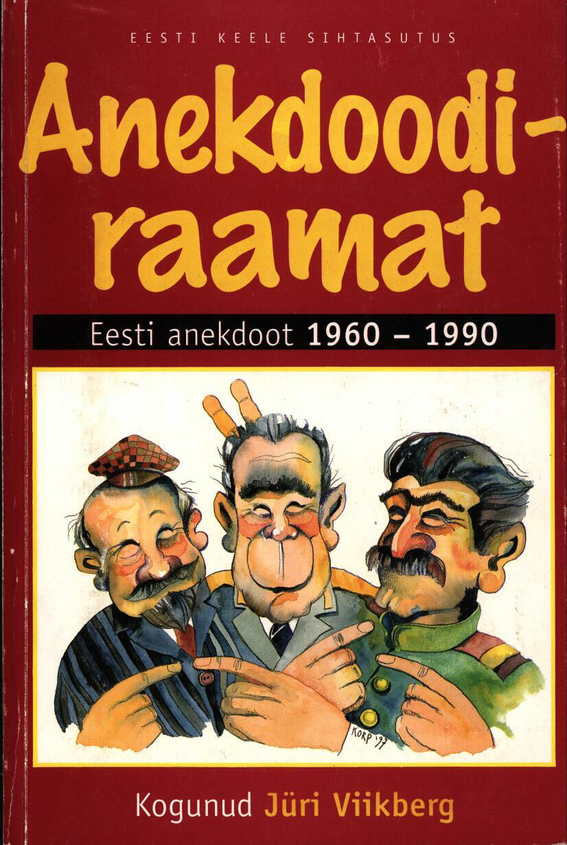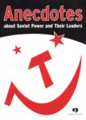

A selection of Viikberg’s jokes (about 2300 verbal texts, plus a small number of droodles) was issued in 1997 under the title “Anekdoodiraamat: Naeruga eilsest: eesti anekdoot 1960–1990” (A book of anecdotes: laughter from yesterday: Estonian anecdotes 1960–1990) and reprinted in 2004. In 2003 an even smaller selection of Viikberg’s joke material was published in English – “Anecdotes about Soviet Power and Their Leaders: Collected from Estonia 1960–1986”.
Another main source, alongside Viikberg’s book, was collected by my wife Luule Krikmann (about 550 joke texts transcribed from 1965–1989, 47 of them undated) – see:
http://www.folklore.ee/~kriku/HUUMOR/soviet.htm
About 800 texts from later writings by Kadi Sarv on children’s political anecdotes were used as supplementary material – see:
Poliitiline anekdoot I (http://www.folklore.ee/tagused/nr1/nalinet.htm)
Poliitiline anekdoot II (http://www.folklore.ee/tagused/nr2/nali2.htm)
Poliitiline anekdoot III (http://www.folklore.ee/tagused/nr4/nali3.htm)
Poliitiline anekdoot IV (http://www.folklore.ee/tagused/nr5/nalinet4.htm)
Poliitiline anekdoot V (http://www.folklore.ee/tagused/nr6/nalinet5.htm)
Sarv 1994 (= http://www.folklore.ee/rl/pubte/ee/cf/lipitud/Mina%20tahan%20ka.html)
In English: Sarv 1997 (= http://www.folklore.ee/folklore/vol5/kadi.htm)

2. Two main presumptions

First of all, I tried to test two strong suppositions I held:
1) that the period of Brezhnev’s rule (and particularly the last part of it) was a golden era of joke-making in the former USSR and perhaps in the countries of the Socialist bloc in general;
2) that the great amount of joke material (especially political jokes) that circulated in Estonia in the Soviet period was of Russian origin.

The histogram below shows the summary numbers of texts annually recorded by J. Viikberg and L. Krikmann in the period 1959–1990.

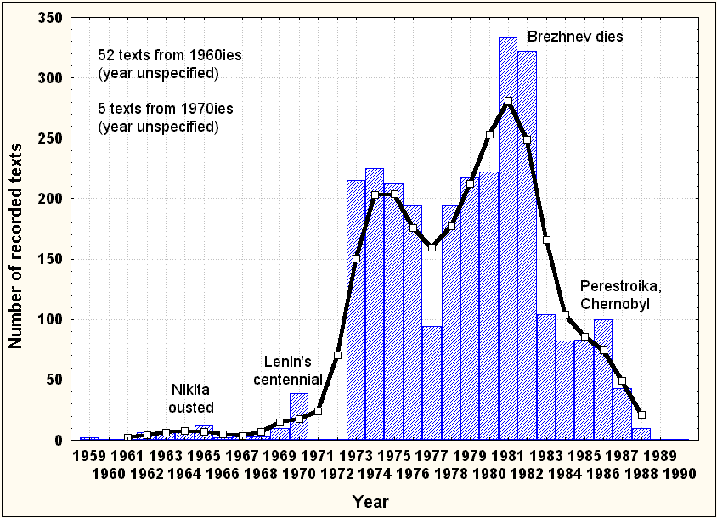

Of course, the statistical resultant from such folkloric material generally reflects two overlapping parameters: 1) the intensity of the tradition (in our case, joke telling) itself, and 2) the intensity of collecting activity. Perhaps our statistics only display the intensity of the joke-telling tradition of the 1960s as implausibly low due to fear of and/or lacking interest in collecting such problematic material. Viikberg only began active collection in the 1970s, and practically all of his records that fall under the category ‘1960s’ are retrospective reminiscences. Nevertheless, the frequencies clearly indicate fluctuations connected with Khrushchev's removal (1965) and Lenin’s centennial (1970). I can neither prove nor deny Graham’s apocryphic reports on alleged attempts by the Soviet security organs to control and canalize jokes: “The Chapaev cycle, for example, was by some accounts was created in the bowels of the Lubianka in the late 1960s as a means of drawing satirical attention away from Lenin as his 1970 centennial approached” (2003: 102). Anyway, it is clearly impossible to ascribe the explosive outburst of jokes in the “Brezhnev era” (and particularly in the last two years of his life) to collecting circumstances. The following two years under the rule of the “Kremlin gerontocrats” Andropov and Chernenko brought about a sharp decrease in joking, Gorbachev’s perestroika with its anti-alcohol campaign and the Chernobyl events in 1986 only managed to cause a slight increase, but the following rapid upsurge of ideas about national independence very soon extinguished the appeal of Soviet jokes once and for all.

To test my other supposition about the strong Russian influence on Soviet Estonian jokes ~ high percentage of plots and motifs borrowed from Russian, I tried to find Russian (exact or at least approximate) equivalents of Estonian plots found in some more “politically-oriented” and/or “Russian-smelling” thematic chapters of Viikberg’s book. In order to accelerate this process, I only used material accessible via the Russian search engine Rambler in the Russian Internet, and used no printed sources. Despite the apparent obsoleteness of the topics, the late origin of the Internet texts, and the eventual numerous gaps in the searching, the results turned out to be quite impressive (see the table below).

Thematic | Number | Russian equivalents |  | Originally | Unknown
chapter | of plots | absolute No. | % | Estonian | origin
Juku (~ Rus Vovochka) | 77 | 61 | 79 | 5 | 11
Jew ~ Rabinovich | 78 | 71 | 91 | 1 | 6
Chapaev, Pet’ka, Anka | 88 | 84 | 95 | 0 | 4
Chukchi | 82 | 71 | 87 | 2? | 9
Pushkin | 15 | 5 | 60 | 1? | 9
Lenin | 32 | 30 | 94 | 0 | 2
Stalin | 15 | 11 | 73 | 1? | 3
Khrushchev | 32 | 24 | 75 | 1? | 7
Brezhnev | 116 | 94 | 81 | 2? | 20
Andropov, Chernenko | 19 | 17 | 89 | 0 | 2
Gorbachev | 39 | 23 | 33 | 2–3 | 13
“Men of the Kremlin” | 27 | 14 | 52 | 1 | 12
Heads of state | 26 | 17 | 65 | 0 | 9
Different nationalities | 105 | 90 | 86 | 1 | 14
Sum /Average | 751 | 612 | 81

The percentage of Russian loans was highest for the topics Chapaev (95), Lenin (94), Jew (91), Andropov & Chernenko (89), and Chukchi (87). I purposely left out the chapters on sex, married couples and lovers, doctors and patients, cops, drunkards, animals, as well as instances of absurd, “black” and “English” humour (including jokes about madmen, cannibals, good and bad news, etc.), where the Russian sites themselves may have been strongly influenced by Western jokes and thus have perhaps played only an intermediary role in transferring the jokes to Estonia.
Hyperpopular figures in Russian jokes, poruchik Rzhevsky and Stirlitz, were almost nonexistent in my Estonian empirics. In Estonia, several plots originally connected with Rzhevsky are addressed to other characters, mainly Pushkin or Chapaev. Stirlitz has evidently been too Russian-bound and punning to entrench himself in Estonian jokelore.
In any case, the percentages in the table above are definitely nothing more than minimums that can only increase when the search for parallels continues.

3. The temporal dynamics of the popularity of some characters

As the bulk of the joke records I used were exactly or indefinitely dated, it was easy to estimate the temporal dynamics of some of the most productive joke characters (technically: the relative frequencies with which their names were used) in different intervals in the period 1959–1990. In order to improve the reliability of the results, the 32-year period was divided into four sub-periods:
1) Nikita’s era (1959–1964);
2) early Brezhnev (1965–1973);
3) late Brezhnev (1974–1982);
4) the “oldsters” (Andropov, Chernenko), Gorbachev.
Texts with indefinite dates such as ‘1960s’ and ‘1970s’ were in the “most reasonable” way placed in sub-periods (1)/(2) and (2)/(3) correspondingly.
The percentages obtained are shown in the set of graphs below. I will also add a brief comment to each.

Juku, Chapaev and Jew: the percentages are relatively low; the Jew’s convexity probably corresponds to the waves of their emigration from the USSR, Chapaev’s convexity is inexplicable to me.
The character Chukchi is a relative newcomer in Russian jokelore too – according to Draitser (1998: 75), the Chukchi jokes first appeared in Russia in the early 1970s. Thus their zero occurrence in Estonian jokes of the subperiod (3) may be the result of a fully predictable “phase shift”. The absurdity of Chukchi-lore, however, seems to have been extremely congenial to the surrealistic atmosphere of the vanishing Soviet Union, and hence its productivity increases exponentially through the last two sub-periods.
Soviet leaders from Lenin to Gorbachev have generally been most popular as joke material at the time they were in power and/or in the nearest contiguous periods. The only exception is Lenin, due to the long and grotesque preparations for his centennial in 1970, which became the source of inexhaustible inspiration for Soviet jokers.* The notable superiority of Nikita’s “relative popularity” in period (1) over Brezhnev’s percentage in period (3) – 39 versus 16 correspondingly – may partly result from the erroneous division of the indefinitely dated ‘1960s’ texts between periods (1) and (2), and partly from the fact that the greater general collection usually also involves a larger number of “degrees of freedom”, and thus suppresses the individual frequencies of its constituents.

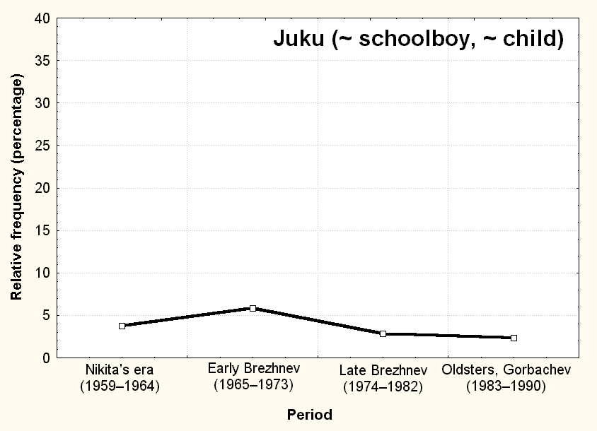 | 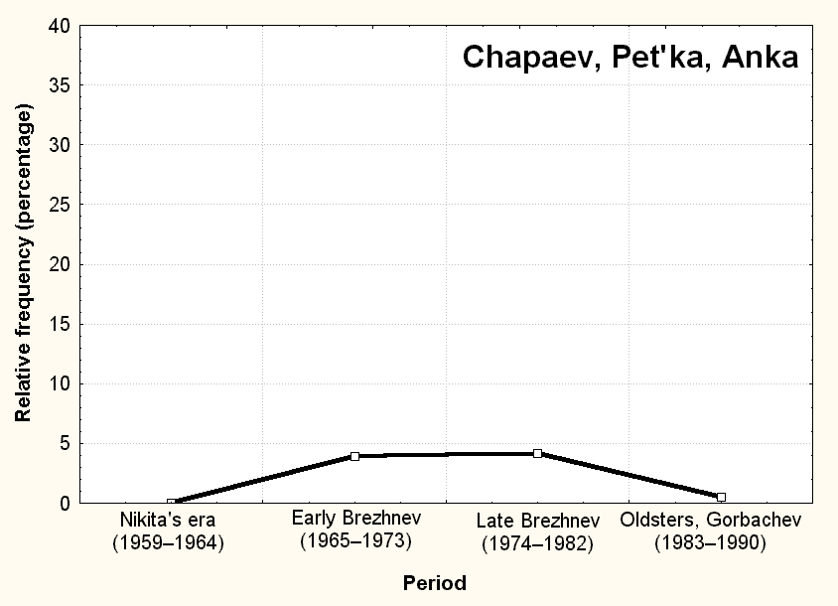
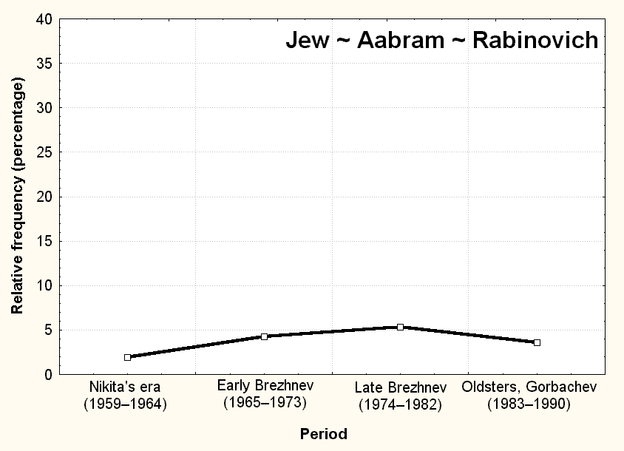 | 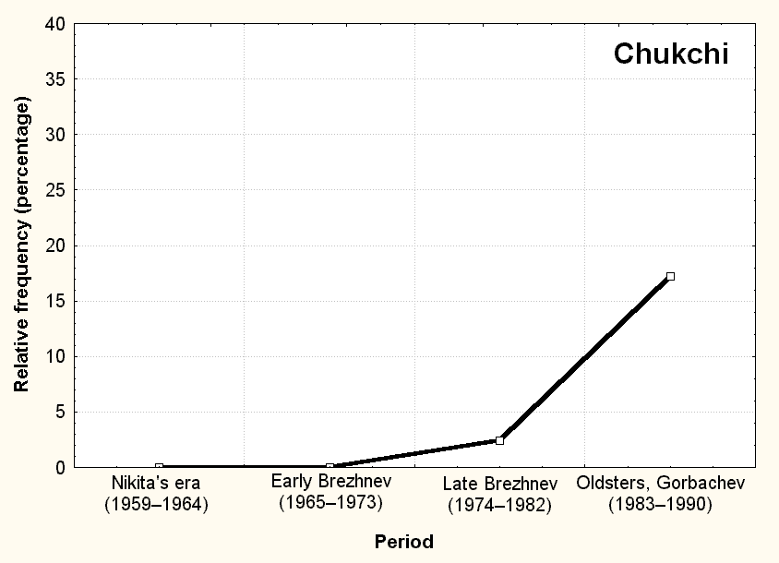
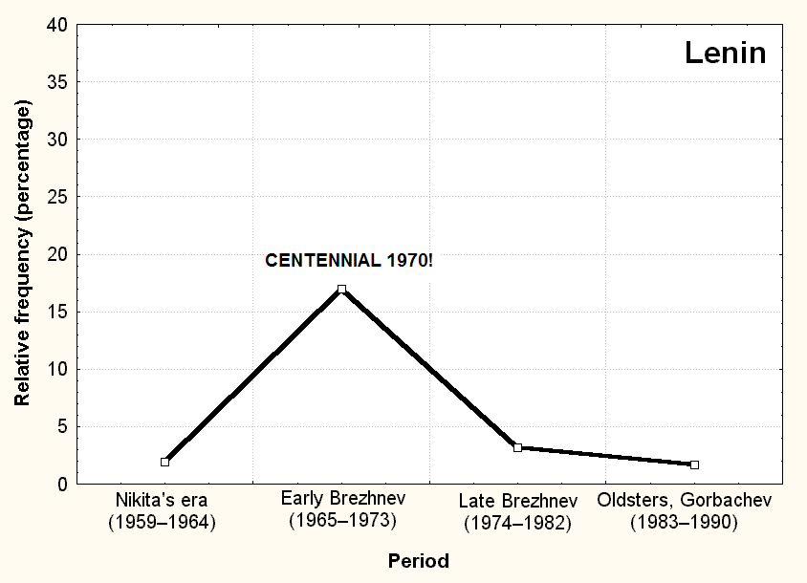 | 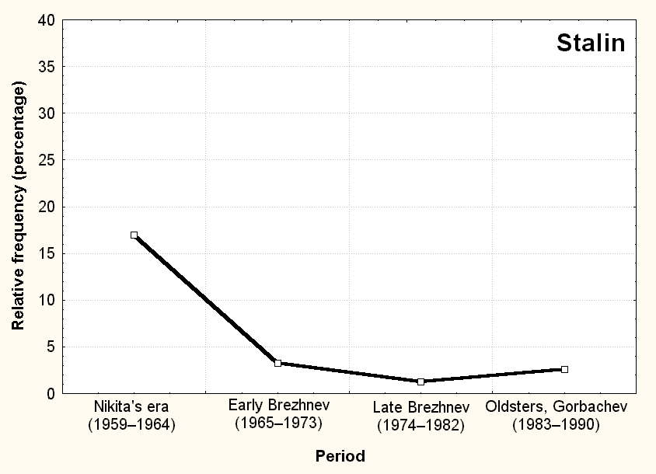
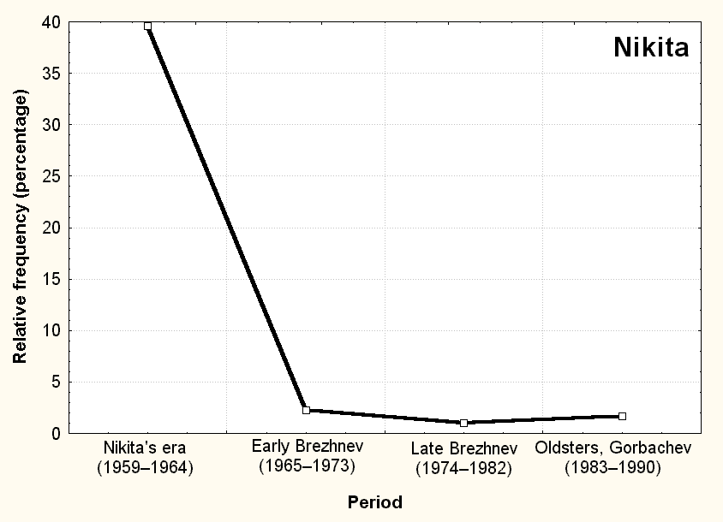 | 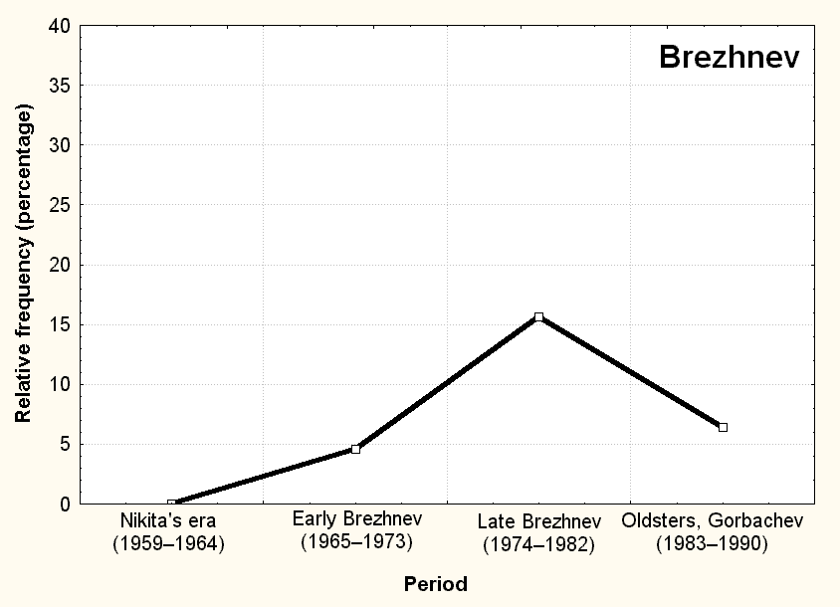
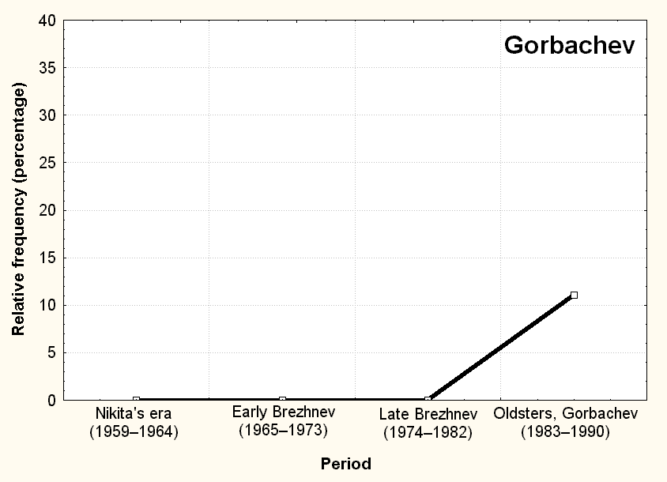

4. Estonian-Russian macaronic texts

I think it would not be wrong to say that of all of the nationalities of the former USSR, the Estonians were least fluent in Russian. Nevertheless, the Estonians of my age and even much younger inevitably knew Russian quite well. They were also very familiar with the Soviet rhetoric, which also sounded most authentic and juicy in Russian. One of the widespread ethnic stereotypes about Russians was their huge store of smear expressions and obscenities, including notorious “mat”, “x - y - i kratkoe” etc., and the virtuosity in using them. It is a linguistic commonplace that such vocabulary sounds much ruder in one’s mother tongue than in another language. For Estonians living in the Soviet era, it was quite customary to use Russian if there was a need to be particularly “expressive”.
The bulk of Soviet jokes was originally created in Russian, admittedly by the Russian urban intelligencija, and exploited in pleno organo the richest phraseological, stylistic and figurative devices of the Russian language. Russian jokes in general tend to be punning (read: untranslatable), or “verbal”, in Salvatore Attardo’s words (see, e.g., 1994: 95 ff.), so their translations more often than not turn out to be merely pale “referential” (in Attardo’s terms, once again) shadows of the originals – take, for example, Raskin’s (1985: 170–177) translations of chastushkas! At the same time, these were irresistibly attractive not only due to their witty, striking and topical content, but also thanks to the wild beauty of their language. I have absolutely no knowledge (and do not know whether anyone else has) of how they were told in culturally and linguistically diverse parts of the USSR. To fill that gap, we should archive and number the essential body of our jokes.
My personal experience, as well as the texts used herein, firmly attest that in Estonia, (anti-)Soviet and other jokes of Russian origin were typically told in macaronic language, maintaining the necessary untranslatable fragments of text in Russian – first of all elements of direct speech, like puns, punchlining formulae, etc. A total of 524 (18%) of my 2856 texts included such fragments in sometimes correct, but much more often, broken Russian.
Essentially, my problem here is not the abundance of macaronic text in Soviet Estonian jokes, but how to make myself understandable using English in four roles simultaneously, i.e.: to translate the Estonian parts of the texts, to convey the two different meanings of the Russian puns, and to use it as a metalanguage to explain the relationships of these two planes of meaning.
I will limit myself to just a few examples:

- Example 1
Tšapai ja Petka tulevad hommikul lakast ja lähevad seina äärde kusele. Petka vaatab Tšapajevi pikka valget ööhamet ja ütleb: – Знаешь, Василий Иваныч, ты прямо как Джавахарлал Неру. Tšapai saab vihaseks: – Совсем не важно, кого я харлал. А как уж харлал, тогда не Неру, а Нюру.
Viikberg, p. 47 (recorded in 1973)
One morning Chapai and Petka come down from the barn’s loft, where they had been sleeping, and take a leak against the wall of the barn. Petka looks at Chapaev’s long white nightgown and says: – You know, Vasili Ivanych, you look exactly like Jawaharlal Nehru. Chapai thinks that “dzhavaharlal” is the past form of some (actually non-existing) foreign verb “(dzhava)harlat”, meaning ‘fucked’, and that “neru” is the accusative form of (also non-existing) woman’s name “Nera”, and gets angry: – It’s none of your business with whom I ‘harled’ (i.e.‘fucked). And if I ‘harled’, then not Nera but Nyura [the last is an everyday Russian woman’s name]
- Example 2
Tšuktš on Moskvas ja läheb restorani sööma. Naisettekandja tuleb ja tšuktš ütleb: – Пожалуйста, мне список блюдей. Ettekandja ütleb: – Вы имеете в виду меню? Tšuktš vaatab teda hindavalt ülalt alla ja ütleb: – Потом посмотрим. Может быть и тебю.
Viikberg, p. 446 (recorded in 1986)
A Chukchi goes to lunch in a Moscow restaurant. The waitress comes, and the Chukchi says to her: “Please, bring me “spisok bljudei”” [which is close in meaning to ‘the list of foods’, but sounds a lot like “bljadei”, i.e. the plural genitive from “bljadj” (whore, hooker)]. It remains unclear which meaning the Chukchi intended, probably the latter. The waitress asks: “Do you mean the menu?” The Chukchi misunderstands once again – he thinks that “menju” is the accusative of the 1st person pronoun “ja” (i.e., “Do you mean me?”; the correct accusative in Russian is “menja”), transposes this broken form to the 2nd person, thus getting “tebju”, and answers: “We’ll see, perhaps “tebju” (i.e. ‘you’ in singular) as well.”
Sometimes Russian is used without obvious necessity, just to make the direct speech sound “more Russian”:
- Example 3
Kaks vanatüdrukut ajavad juttu ja üks räägib teisele: – Ты смотри, как везет Нюрке. Она замужем, у нее любовник аккуратный и мало того, вчера вечером ее изнасиловали.
Viikberg, p. 473 (recorded in 1973)
Two old maids are talking, and one of them says: “Look how lucky Niurka is. She is married, she has an “akkuratnyj” (“good”) lover, and to top it all off – yesterday night she was raped.”

5. Is there something purely Estonian as well?

Of course there is. Viikberg’s book also includes a special chapter entitled “Something Estonian”. I would like to emphasise once again the need for a general register of contemporary jokes – again and again I found myself unable to distinguish jokes of genuinely Estonian origin from adaptations of internationally known jokes to Estonian conditions.
A joke can be regarded as purely Estonian if it proceeds from events that actually took place in Estonia and are unknown and/or not of interest elsewhere, or if the text involves some expressions that cannot be literally translated into another language, such as puns, idioms, rhyming parts, etc., or if it quotes with irony some locus communis of Estonian literature, or if the joke can be considered a parody of some well-known song in Estonian, etc.. Often the different features of “Estonianness” can co-occur in one and the same joke text.
There are two events that seem to have been predominant in stimulating the imagination and inspiration of Estonian joke-makers – the “case of milkmaid Leida Peips” and the 1980 Olympic regatta in Tallinn.
It was customary in the USSR to award people the title of work hero, i.e. hype up some working people, writing about them extensively in papers and electing them to various important “Soviets”, thus presenting them as symbols and icons of the advantages of Soviet power and the working enthusiasm of the Soviet people. The earliest examples from the 1930s were coal miner Aleksei Stakhanov and the first woman tractor driver Pasha Angelina. In the mid-seventies humble Estonian milkmaid Leida Peips was unfortunate enough to attract such unwanted attention, was extensively written about, elected to the Supreme Soviet, personally introduced to Leonid Brezhnev – and pitilessly mocked in Estonian jokes.
I can once again offer only a few examples of purely Estonian jokes, but I again have difficulty explaining their funniness to the non-Estonian public.

Some items from the “Leida Peips cycle”.
Some preliminary tips for understanding:
1) In Estonian, as in any other language, jokes are often made through the use of comical, parodizing acronyms.
2) In Finnish and Estonian, the alliteration reminiscent of old runic songs is one of the main form-constituting features, and a strong tendency towards alliteration can be seen in Estonian folklore in general, including the alliterative formulae of Estonian “home-made” jokes.
3) “Peipsi” is the name of the big lake in the eastern part of Estonia, half of which belonging to Estonia, the other half to Russia. In the seventies, thin milk was called “Peipsi water” (Peipsi vesi).
- Example 4
Tip for understanding: in Estonian the quasi-word pronounced “ell” is a euphemism for “lits” (i.e. ‘whore’, ‘hooker’)
3 suurt L-i: Leida, Lehm, Ljonja.
L. Krikmann, no. 525 (undated)
Literally: Three big “L-s”: Leida, cow, Lionia.
- Example 5
Leidale tuleb külla Ljonja. Uksel on silt LOLL (= Ljonja, olen laudas. Leida). Nuhk hakkab uurima, kes kirjutas. Leida ise kirjutas! [Dateerimata]
[Sama akronüümi teine mõtestus: “Lehm on lüpstud. Leida.”
L. Krikmann, no. 533 (without date)
Lionia (= Brezhnev) comes to visit Leida and finds on Leida’s door a sign that says LOLL (literally: FOOL, actually meant as the abbreviation: “Lionia, I’m in the cowshed. Leida”). A spy begins to investigate who wrote it. [It turns out that] Leida herself wrote it!
Another interpretation of the same acronym: “The cow has been milked. Leida.”
- Example 6
Tip for understanding: In Estonian there are no voiced plosives. Thus the sound sequence “püsti” can mean the genitive or partitive case of büst (‘bust’), as well as ‘standing’, ‘standup’, ‘upright’.
Leida juurde tuleb kunstnik ja ütleb: "Teeme büsti." Leida: "Ei ole aega." — "Teeme büsti ruttu ära, see ei võta palju aega." – "Eluaeg ei ole püsti teinud, teeme ikka pikali."
L. Krikmann, no. 537 (undated)
A sculptor comes to Leida and says: “Let’s make a bust (of you) [understood as ‘do it (i.e. sex) standing up (“püsti”)].” Leida: “I have no time.” – “We’ll do the bust [do it standing up] quite quickly, it won’t take long.” – “I have never before done it standingup, let’s do it lying down instead.”
- Example 7
Leida Peips kirjutab Brežnevile: – Kas te mäletate veel, kuidas me koos magasime? Vastus tuleb kiiresti: – Kust te selle võtate? Midagi sellist pole ju olnud! – Kuidas pole olnud? Me magasime koos Kongresside Palees, teie presiidiumis, mina saalis.
Viikberg, p. 491 (1975)
Leida Peips writes to Brezhnev: “Do you still remember how we slept together?” Brezhnev rapidly replies: “What are you talking about? Nothing like that has ever happened!” – “What do you mean never happened? We slept together in the Palace of Congress – you were in the presidium, I was in the hall.”
Some of the “Leida jokes” are obviously mere adaptations of much more widely-known jokes.
- Example 8
Esimees ütleb Leidale, et homme tuleb reporter sinult intervjuud võtma. "Mis tuu om?" küsib Leida. Esimees: "Ma ka ei tea, aga igaks juhuks pane puhas kombinee selga."
L. Krikmann, no. 528 (undated)
The kolkhoz chairman says to Leida: “Tomorrow a reporter will come to interview you.” – “What about?” Leida asks. “I don’t know either, but put on a clean slip, just in case!”
The same motif is extensively represented on the Russian Internet.
- Example 9
Leonid Brežnev hakkab sõitma Eestisse Leida Peipsile külla. Päris täpselt ei tea, kuhu sõita, aga õnneks oli tee ääres teeviit – Peipsi 25 km. Autojuht keerab viidatud teele, kupatavad edasi. Talvine aeg, ümberringi vaadata vähe. Korraga hakkab auto läbi jää vajuma. Lähedal on sikuskimehi, Brežnev hüüab appi ja lubab täita igaühe soovid. Üks soovib maja, teine autot, kolmas mõtleb, mõtleb ja soovib endale lõpuks tinakirstu. No nii, mees päästetakse ära, sai kuivad riided selga ja kuuma ahju juurde. Siis meenutab Brežnev meeste soove ja vangutab pead: – Autost ja majast saan ma aru, aga miks sina tinakirstu soovisid? – No kui külarahvas teada saab, kelle ma ära päästsin, läheb mul kirstu kohe varsti vaja.
Viikberg, p. 489 (1975)
In winter Brezhnev comes to Estonia to visit Leida Peips. He does not know exactly where she lives, but then he sees the signpost “[Lake] Peipsi 25 km”, and his chauffeur turns toward the lake. They are driving, and suddenly the car begins to sink through the ice. Fortunately there are some winter fishermen nearby who save Brezhnev’s life. The thankful Brezhnev promises to do for them whatever they want. One wants a house, the second a car, but the third wants a tin coffin. The puzzled Brezhnev asks why he needs a coffin. “Well, when the village people find out who I saved, I will soon need a coffin.”
Cf. the German text under no. 39 in Krikmann 2004:
Stalin, der nicht schwimmen konnte, badet im Schwarzen Meer und ist dabei, zu ertrinken. Ein Landsmann rettet ihn. “Welchen Lohn möchtest du,” fragt Stalin. “Sagen Sie niemandem, dass ich Sie gerettet habe. Das soll mein Lohn sein.”
http://www.matrjoschka-online.de/archiv/marginalien.htm

Some jokes punning with the names of Karl Vaino and Vaino Väljas
Tips for understanding the following jokes:
1) the surname of the first man and the forename of the second man coincide;
2) The Estonian väljas also means ‘out’, ‘outside’, ‘outdoors’.
- Example 10
At the end of the 1980s, when the “singing revolution” began in Estonia, the detested Karl Vaino, half-Estonian General Secretary of the Estonian Communist Party, was replaced with the more democratically-minded man, Vaino Väljas, I saw students at one demonstration wearing the punning slogan HURRAH, VAINO VÄLJAS! the first reading of which is: ‘Hurrah, Vaino Väljas!’, and the other: ‘Hurrah, Vaino is out!’
- Example 11
Another modification of punning with the above-mentioned names:
– Ei tea, kus Karl Vaino nüüd ka töötab? – Ilmajaamas. – Mis ta seal teeb? – Vaatab aknast välja, et kas väljas on juba külm.
Viikberg, p. 513 (1988)
“I wonder where Karl Vaino is working now.” – “At the weather station.” – “What is he doing there?” – “He’s looking out the window to see... [the punchline end has two readings:] 1) …whether it is already cold outdoors”, and 2) …whether Väljas is already cold [i.e. dead]”.

Some other punning jokes
- Example 12
Tip for understanding: the Estonian word võitu has two homonymous meanings:
1) the partitive case of the substantive võit (‘victory’); 2) the headword of Estonian compound adjectives and adverbs it means ‘a bit (too) ...’, ‘somewhat...’ (cf. Russian -вато).
Sotsialismi 3 võitu: vähevõitu, sitavõitu, kallivõitu
L. Krikmann, no. 501 (1987)
Its “purely referential” English approximation would then be: What are the three great victories of socialism? – Somewhat too few [goods], somewhat too shitty, somewhat too expensive.
- Example 13
Mees läheb õhtul valveapteegi juurde ja annab kella. Keegi pistab ukse vahelt nina välja ja küsib: – Mis vaja? – Kas teil preservatiive on? küsib mees. – Ei. Otsas juba. – No andke siis otsast.
Viikberg, p. 489 (1975)
The “referential” translation: In the evening a man goes to the 24h pharmacy and asks: “Do you have condoms?” – “No, [the following “Otsas juba” has two different readings: 1) ‘...we have already run out of them’ and 2) ‘...they are already on the tip’)”. – “OK, then give me one from the tip!”
- Example 14
Tip for understanding: The Estonian phrasal verb läbi tõmbama has two different meanings: 1) ‘cross out’, ‘delete’; 2) as an idiomatic expression: ‘fuck’, ‘shag’.
Neiu saab 16-aastaseks ja läheb passilauda passi saama. Saab passi kätte, aga perekonnaseisu lahtrisse on kirjutatud "lesk". Läheb miilitsaülema juurde protestima ja see tõmbab "lesele" kriipsu peale. Passiülem kirjutab õiendi: – Miilitsaülema poolt läbitõmmatud "lesk" lugeda "neiuks".
Viikberg, p. 494 (1977)
A 16-year-old girl goes to the passport bureau to receive her first passport. She finds the entry “widow” in her marital status column and goes to the head of police to protest. The head of police crosses out the word “widow”. The head of the passport bureau adds the correction:... [the amendment has two readings: 1) “(The word) “widow” crossed out by the head of police is to be considered a maiden”; 2) (punctuation disregarded) “the widow shagged by the head of police is to be considered a maiden”]

Some examples of “grammatical jokes” and jokes on toponyms
- Example 15
Kas tead, et eesti keeles käänatakse asesõnu nüüd uut moodi: minantropov, sinantropov, temantropov...?
Viikberg, p. 505 (1982)
Do you know that Estonian pronouns are now declined in a new way: “I-antropov”, “you-antropov”, “he-antropov”...?
Estonian personal pronouns in singular are: mina, sina, tema.
“Sinantropov” is a clear allusion to “Sinanthropus”.
- Example 16
There is a joke cycle about Soviet “newlang” names of cases of Estonian nouns and mood of Estonian verbs that need more extended explanation.
Tip for understanding: In Estonian, nouns have 14 cases, with parallel Latin-derived names and (now somewhat out-of-date-sounding) names based purely on Estonian stems. These “puristic” terms are in principle “gerund”-adjective forms of certain Estonian verbs, ending in -tav, for some cases, -ütlev (i.e. approximately -ing and -saying in English). For example, nominative is nimetav (i.e. “naming” in a painfully literal translation), genitive is omastav (literally: “possessing” or “assuming”), illative is sisseütlev (literally: “to-inside-saying”), elative is seestütlev (literally: “from-inside-saying”), comitative is kaasaütlev (literally: “together-saying”), abessive is ilmaütlev (literally: “without-saying”), and so on. Most purely Estonian names for mood categories are derived analogically: imperative is käskiv kõneviis (literally: “commanding” or “ordering” mood), conditional is tingiv kõneviis (literally: “conditioning” mood), etc.
Elza Grechkina, a former disliked Minister of Education of the Estonian SSR, was said to have proposed to change the grammar of Estonian, removing some allegedly obsolete cases and adding new cases, such as mittemidagiütlev (literally: “nothing-saying”, i.e. ‘meaningless’, ‘senseless’), väheütlev (literally: “little-saying”, i.e. ‘uninformative’), äraütlev (literally “away-saying”, i.e ‘refusing’), ilmaolev (literally: “without-being”, i.e. ‘doing without’ or ‘deprived of’), äravõetav (literally: “that which can be taken away”), imestav (‘wondering’ or ‘surprising’), ihaldav (‘desiring’), mõnitav (‘scoffing’), and new verb moods like umbusaldav (‘distrusting’) and kõhklev (‘hesitating’).
Cf. Viikberg, pp. 504–505; Luule Krikmann, no. 352 (all records from 1982).
- Example 17
Kuidas pöörab Juku sõna "ehitama"? Koolis eesti keele tund ja õpetaja laseb Jukul pöörata sõna "ehitama". Juku hakkab pihta: – Mina ehitan, sina ehitad, tema ehitab, meie ehitame, teie ehitate, nemad kolivad sisse.
Viikberg, p. 18 (1975)
How does Juku conjugate the Estonian verb “build”? – “I build, you build, he/she builds, we build … they move in.”
This “grammatical joke”, though not necessarily Estonian in letter, is nevertheless very Estonian in spirit. In the Soviet period, especially in Tallinn, whole new suburbs were built, but the new buildings were mostly populated by the migrant “aliens” from the East.

Some jokes based on toponyms and anthroponyms
- Example 18
Still another joke about the new suburbs. In Tallinn their names typically ended in “-mäe” (genitive of “mägi”, i.e. ‘hill’), like Mustamäe (literally “Black hill”, Lasnamäe (literally perhaps “Spade hill”) and Õismäe (literally “Blossom hill”). On the other hand, there are several cemeteries in Tallinn with the same ending, like Rahumäe (literally “Peace hill”) and Pärnamäe (literally “Linden hill”).
Iivan Käbin on Moskvas ja peab seal aru andma, kuidas edeneb Tallinna elanike paigutamine. – Üldjoontes on asi lahendatud, seletab Käbin. Venelased lähevad Mustamäele, Õismäele ja Lasnamäele, eestlased Rahumäele ja Pärnamäele.
Viikberg, p. 491 (1975)
Ivan Käbin (the one-time leader of the Estonian Communist Party) is in Moscow and is reporting on the placement of residents of Tallinn in new suburbs. “In general the problem is solved,” he tells, “the Russians will go to Mustamäe, Õismäe and Lasnamäe, and the Estonians to Rahumäe and Pärnamäe.”
- Example 19
Perhaps the greatest of Soviet Estonian puns I know is that about Gustav Naan, an Estonian Marxist philosopher and alleged encyclopaedist, one of the rewriters of Estonian history in the Marxist spirit and later cosmologist and charismatic freethinker to some people, despised careerist and schemer to others.
The pun was very topical in the 1980s, but is only represented in my material by one single record:
Mis on erinevat Soomes ja Eestis? – Noh? – Soomes on pestav tapeet ja Eestis on Gustav Naan.
Viikberg, p. 504 (1982)
What’s the difference between Finland and Estonia? – What? – In Finland they have washable wallpaper, we in Estonia have Gustav Naan.
Tips for understanding:
1) Estonian deverbal adjectives ending with -tav are equivalent to these ending with -ble in English;
2) as there are no voiced plosives in Estonian, the pronunciations of the words Gustav and kustav are equal;
3) kustav means ‘pissable’, which is quite nonsensical in both English and Estonian.

Jokes based in various ways on various popular songs
- Example 20
Isaak Dunaevski wrote music for many Soviet films in the 1930s. One of his hit songs is the brave and optimistic “Марш веселых ребят” from the movie “Веселые ребята” (1934), with the beginning lines Легко на сердце от песни веселой, / Она скучать не дает никогда... The beginning line of its second stanza is Нам песня строить и жить помогает..., which was translated into Estonian as “Meil laulud aitavad elada, võita” (Songs help us to live and win). It was enough to remove the comma from the clause to get a terrific pun “Songs give us live without butter”.
Tip for understanding: the homonymous võita is 1) the da-infinitive from the verb võitma (‘to win’) and 2) the abessive case of the substantive või (‘butter’).
Cf. also L. Krikmann, no. 238, 297 (1981/2)
- Example 21
Another popular song in 1960s Estonia was “On kallis mulle kodupaik” (“My home place is dear to me”) by Estonian composer Gennady Podelski. Its melody sounds nice and its content (as is generally the case with popular songs) is absolutely trivial, especially in literal translation without any support from melody, rhyme, and rhythm: My home place is dear to me, / it’s so good to be here, / it’s so good to be here, / so many beautiful impressions / you always take along from here”, and so on in the same spirit.
It turned out to be possible to make something out of this apolitically sweet duff.
See the following:
Kuidas ja mida laulavad üldlaulupeol ühendkoorid? – Eestlased laulavad: "On kallis mulle kodupaik ..." Ja venelased: "... nii hea on olla siin, nii hea on olla siin ..."
Viikberg, p. 502 (1981)
How and what the mass choirs sing at the song festival? – The Estonians sing: “My home is dear to me...”, and the Russians: “...it’s so good to be here, it’s so good to be here...”.
The last line was usually performed with an awful Russian accent.
- Example 22
The “normal” Estonian translation of the well-known nursery rhyme What Are Little Girls Made Of? ... What Are Little Boys Made Of? is quite close to its original: boys are made of “hiirest ja konnast ja kutsika hännast” (i.e. a mouse and a frog and a puppy’s tail), and girls, mutatis mutandis, of “suhkrust ja jahust ja maasikavahust” (i.e., sugar and flour and strawberry cream).
But see the following “ethno-political” turn!
Millest on tehtud väikesed venelased? — Tatist ja vatist ja joptvojumatist.
L. Krikmann, no. 120 (1978)
Literally: What are little Russians made of? – Snot and cotton and “motherfucker”.
- Example 23
Tips for understanding:
1) there is a semi-folkloric belief that stutterers do not stutter when singing;
2) there is a popular nonsensical children’s song in Estonia “Hiir hüppas, kass kargas, / vana karu lõi trummi, / kirp annast välja, / nahkpüksid jalga” (˜ The mouse jumped and the cat sprang and the old bear beat the drum, / throw the flea out the window, / put on lederhosen);
3) one of Tartu’s poorer districts is called Supilinn (“Souptown”), in which there are streets like Pea Street, Bean Street, Pod Street, Potato Street, Melon Street, Berry Street and others.
Maja läks põlema ja kokutaja pidi teatama tuletõrjesse. Veider nähtus küll, aga lauldes kokutajad ei kokuta ja nii laulis see ("Hiir hüppas, kass kargas" viisil) telefonitorusse: – Meil Herne tänavas põleb üks maja! Torust vastati: – Trillallaa-trallallaa, pane toru ära!
Viikberg, p. 490 (1975)
A house caught on fire and a stutterer had to call the fire department. It’s an interesting phenomenon that when people sing they don’t stutter, and thus the stutterer called the fire department and sang: “In our Pea Street / there’s a house on fire...”. The fire department dispatcher sang in response: “Trillalla-trallalla, / hang up the handset!”
I am not sure that this joke was born in Tartu, but non-Estonian equivalents are hard to find for the reason that there is no international joke index.

The two graphs below show relative frequencies (percentages) of macaronic Estonian-Russian texts (see the left) and texts of Estonian origin, including adaptations (see the right) through our four subperiods. Both trends are increasing. The tendencies are yet not incompatible or contradictive, but rather indicate, on the one hand, the growth of general linguistical diversity in Estonian joke texts (as the percentage of text fragments in English, German, Latin etc. also increases), and growth of national self-confidence, on the other.

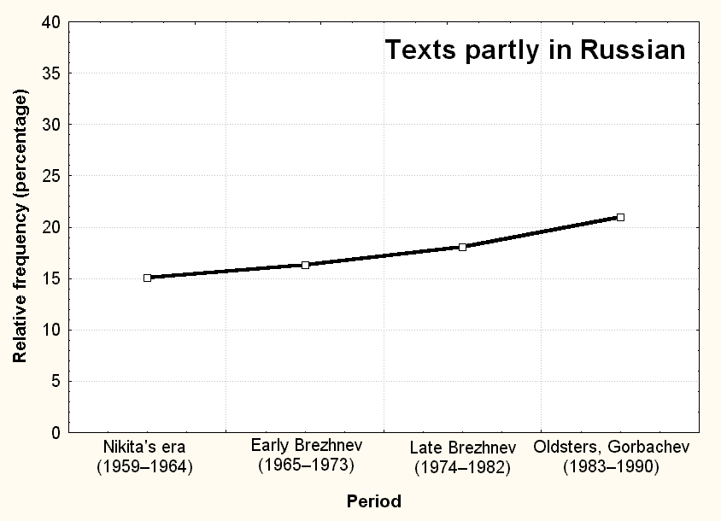 | 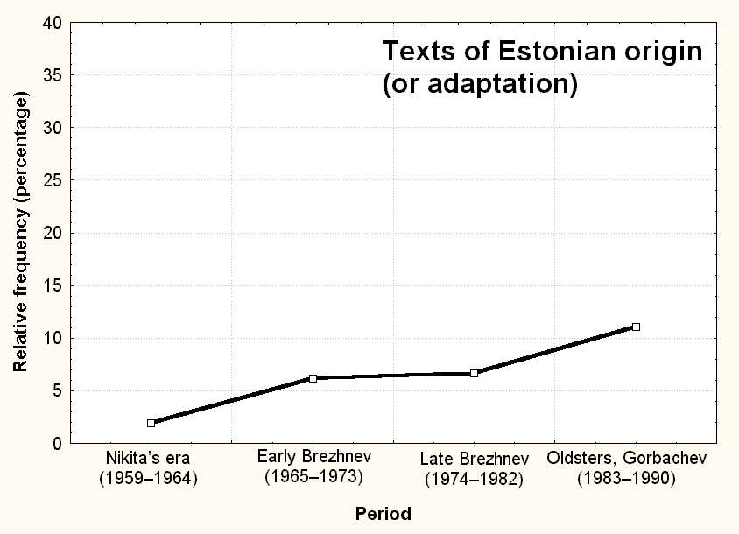

In the final part of my presentation I would like to reiterate some general circumstances proving the need for a general register of contemporary jokes.

6. The internal typological structure of the repertoire of canned jokes

Perhaps it feels regrettably non-postmodernist, too “folkloristic” and “archivistic” to speak of the typological structure of the international store of canned jokes. In spite of that, all of my previous experience with several folklore genres of several nations encourages me to argue that such a structure does really exist and that moreover, it is important to know.
No joke as an individual (actualized orally or put on paper or Internet) text exists in a vacuum, but is in various ways – associatively, genetically, or otherwise – connected with other texts stored in the memories of and shared between the members of joking communities. They also interact with events and situations of the external world, retrieving jokes from these memories and restoring them in other memories when they are told. Nor is the sum total of hitherto told and/or stored jokes a chaotic mess, but a multidimensional set of natural classes consisting of natural typological units (“joke items”, or plots) whose borders are in some cases clear-cut and in some cases hopelessly fuzzy.
There are powerful joke items that are capable of wandering from country to country and from language to language. Take, for example, the majority of East European political jokes published by Banc & Dundes (1990 [1986]), known in many countries of the Socialist Bloc and displaying manifold variation, or the most widespread items from my Stalin book (Krikmann 2004), like the “Who sneezed?” joke (no. 1), the joke about the stopped train of socialism (no. 2), about numerous camps of collected jokes (no. 3), and many others. There are other joke items that have little or no chance of crossing the borders of a particular language, simply because they are punning – see, e.g., my examples of Estonian political puns above.
My experience with large archive material on some genres of Estonian and Finnic folklore also suggests that the typological items (in the case of jokes, different plots) usually tend to follow
a Zipfian type of frequency distribution: there is a great number of infrequent (“feeble”, local) plots, a mean number of plots of “medium size” and a small number of very frequent (“mighty”, global) plots.
It is intuitively credible and has already been suggested by numerous authors that the collapse of the Socialist system in Eastern Europe in the late eighties and early nineties has brought about dramatic changes in the European joke stock that deserve to be ascertained and investigated. In order to do that, we need to know what was the state of affairs before the changes took place. For both of these purposes we need a “numbered list of contemporary jokes”.

7. The three generic content clusters of Soviet Estonian jokes

The joke material in Jüri Viikberg’s book is organized in a certain two-tiered system of categories, partly oriented to content, partly to the form of jokes. Viikberg also includes a certain number of droodles and conundrum-form practical jokes. The lower-level groups are most frequently focused around certain politically, ethnically, sexually or otherwise specified key personae, such as leaders of the Soviet Union and other countries, for instance Chapaev, Chukchi, Jew, Russian, Estonian, Juku, married couples, cops, doctors, madmen, cannibals, various animal characters, etc. Thus Viikberg’s system largely involves levels (2), (3) and (4) of the GTVH model of jokes proposed by Attardo and Raskin (1991), that is, narrative strategies (“genre forms”), targets (butts, personalized objects), and situations.
Politicalness, ethnicity and sexuality – the principal “scaffolding axes” or “moving powers” of jokes largely investigated by Raskin (1985 and later), Davies (1990 and later) and many others – do not provide a device for splitting the general joke store into three mutually exclusive parts. These are instead factors or aspects that often appear in twos and threes together in the same joke. Besides, they do not exhaust the whole set of the criteria of funniness.
I will now attempt to briefly delineate my own somewhat fuzzy and incomplete vision of the categorisation of Soviet Estonian jokes (and perhaps jokes of many other peoples of the former Socialist bloc) at a more generic level.
Ordinary treatments of ethnicity in Soviet jokes by Draitser (1998), Shmeleva & Shmelev (2002) and others usually share the Russo- and/or Judocentric point of reference, and thus also share Christie Davies’ view of the one-sided, “from centre to periphery”, “from dominant to dominated”, “from modern to obsolete”, “from higher to lower” etc. direction of ethnic mockery. As my colleage Liisi Laineste has shown earlier, the ethnic jokes of Soviet Estonia do not precisely follow Davies’ postulates: “…the Estonian material includes tendencies and single phenomena which cannot be explained through the theory [of Davies] – for example, why the jokes are told upward, i.e. on the lower social and economical level, and in periphery (in geographical sense) jokes are made on ethnic groups higher up the social scale (e.g. Estonians about the Russians)” (2005: 21). The very same may very likely hold true about the jokes of the non-Russian part of the former Socialist bloc in general. These nationalities shared the stereotype of Big Brother. Big Brother spoke in Russian and embodied danger for the suppressed nationalities, not only due to its tanks and economic pressure, but also did its best to extinguish and assimilate the non-Russian languages, at least within the borders of the USSR. Therefore it is not ungrounded to presume that political and ethnic aspects were largely interwoven and blended in the jokes of the suppressed peoples of the Socialist bloc.
At the same time, Soviet Estonian material provided by Viikberg and Krikmann, as well as Russian material in corpore, clearly shows a parallel opposite tendency – the disappearance of former political and/or ethnic markers from some joke characters, such as Chapaev, Chukchi, Lenin, or Stalin.
Furthermore, various scenarios of development are possible. If the cluster of joke plots labelled with a certain character’s name is large enough and thus has the necessary amount of inertia, the name label can survive, despite it being deprived of its former political and/or ethnic markers, referring henceforth to some mythologized or “trickster-like” character. If an individual plot in which they occur happens to possess other values beside political and ethnic ones, it can continue its existence, perhaps in some modified form and with shifted emphases.
What are these “other values”? First of all, the sexual factor that has been salient in jokes of all eras and is now all the more supported by the tendencies of the cult of sex and the rampant sexual freedom in contemporary society.
The last peripheral part of Viikberg’s book displays the supposedly strengthening “third factor”. In contemporary jokelore there are already large and probably expanding areas of absurd and “black” humour, like the dystrophic cycle in Russia or the Orbit cycle in Estonia and elsewhere, as well as cannibal jokes, good and bad news jokes, etc., where Bergson’s “anaesthesia of the heart” seems to be more than total, the fundamental laws of nature and logic seem not to apply, the whole view of the world obtains a surrealistic character, allegories obtain a new, hitherto unexplained quality, etc..
Thus at the highest generic level, the store of Soviet Estonian jokes seems to divide into three large and fuzzy groups:
1) the cluster of ethno-political jokes of mainly Russian origin and with a decreasing trend of future development;
2) the cluster of sexual jokes of a universal nature and with a continuing or increasing trend of development:
3) the cluster of abstract and/or absurd and/or reality-distorting jokes of mainly Western origin and with a strongly increasing trend of development.
Of course, the above postulates should not be taken too seriously. And once again, in order to specify, corroborate or refute them (or any different hypotheses), we need a “list of numbered jokes”.

Note

* I can neither prove nor deny Graham’s apocryphic reports on alleged attempts by the Soviet security organs to control and canalize jokes: “The Chapaev cycle, for example, was by some accounts was created in the bowels of the Lubianka in the late 1960s as a means of drawing satirical attention away from Lenin as his 1970 centennial approached” (2003: 102).

References

Attardo, Salvatore 1994. Linguistic Theories of Humor. Berlin–New York: Mouton de Gruyter.
Attardo, Salvatore & Raskin, Victor 1991. Script theory revis(it)ed: joke similarity and joke representation model. HUMOR: International Journal of Humor Research, 4-3/4, pp. 293–347.
Banc, C. & Dundes, Alan 1990. You Call This Living? A Collection of East European Political Jokes. Athens–London: The University of Georgia Press.
Davies, Christie 1990. Ethnic Humor Around the World: A Comparative Analysis. Bloomington–Indianapolis: Indiana University Press.
Draitser, Emil 1998. Taking Penguins to the Movies: Ethnic Humor in Russia. Detroit: Wayne State University Press.
Graham, Seth Benedict 2003. A Cultural Analysis of the Russo-Soviet Anekdot. PhD Dissertation. University of Pittsburgh.
http://etd.library.pitt.edu/ETD/available/etd-11032003-192424/unrestricted/grahamsethb_etd2003.pdf
Krikmann, Arvo (ed.) 2004. Netinalju Stalinist – Интернет-анекдоты о Сталине – Internet Humour About Stalin. Tartu: EKM, EKFK.
Laineste, Liisi 2005. Targets of Estonian Ethnic Jokes Within the Theory of Ethnic Humour (Ch. Davies). Folklore, vol. 10, issue 29, pp. 7–24.
Raskin, Victor 1985. Semantic Mechanisms of Humor. Dordrecht–Boston–Lancaster: D. Reidel Publishing Company.
Shmeleva, Elena & Shmelev, Aleksei 2002. Русский анекдот: Текст и речевой жанр. Москва: Языки славянской культуры.
Viikberg, Jüri 1997. Anekdoodiraamat: Naeruga eilsest: eesti anekdoot 1960–1990. Tallinn.

